1. Tag / Samstag, 5. Juli 2008
(72 mi – 116 km)

06.35 AC9161 Abflug Wien
08.00 01:25 Ankunft Frankfurt

13.45 AC845 Abflug Frankfurt
15.50 10:05 Ankunft Calgary

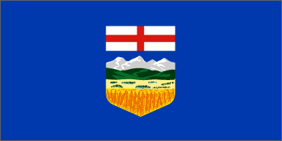 | alberta
 | 0 | calgary international airport
72 | 72 | Canmore

2. Tag / Sonntag, 6. Juli 2008
(? mi – ? km)

 | 72 | Canmore
150 |  | CALGARY ?
50 |  | banff NATIONAL PARK ?

3. Tag / Montag, 7. Juli 2008
(391 mi – 629 km)

 |  | banff NATIONAL PARK
50 | 122 | Lake Louise
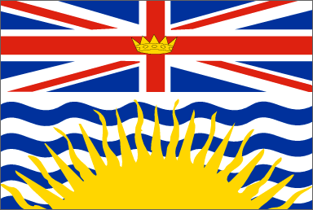 | british columbia
 |  | yoho NATIONAL PARK
51 | 173 | Golden
69 | 242 | Radium Hot Springs
83 | 325 | Cranbrook
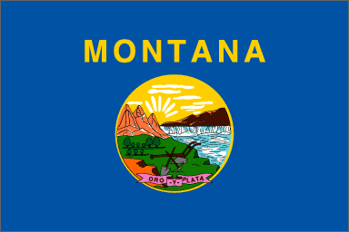 | montana
69 | 394 | Eureka
69 | 463 | Kalispell

4. Tag / Dienstag, 8. Juli 2008
(406 mi – 653 km)

117 | 580 | Missoula
127 | 707 | Butte
72 | 779 | Belgrade
90 | 869 | West Yellowstone

5. Tag / Mittwoch, 9. Juli 2008
(124 mi – 200 km)

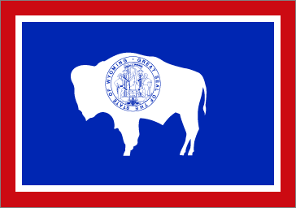 | wyoming
47 | 916 | yellowstone national park – West thumb
37 | 953 | yellowstone national park – canyon
 | montana
40 | 993 | West Yellowstone

6. Tag / Donnerstag, 10. Juli 2008
(125 mi – 201 km)

 | wyoming
40 | 1033 | yellowstone national park – canyon
37 | 1070 | yellowstone national park – mammoth hot springs
 | montana
48 | 1118 | West Yellowstone

7. Tag / Freitag, 11. Juli 2008
(285 mi – 459 km)

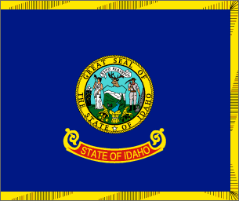 | idaho
 |  | Mesa Falls Scenic Byway (S. 260)
110 | 1228 | Idaho Falls
65 | 1293 | Arco
 |  | craters of the moon national monument
83 | 1376 | Shoshone
 |  | Shoshone Falls
27 | 1403 | Twin Falls

8. Tag / Samstag, 12. Juli 2008
(452 mi – 727 km)

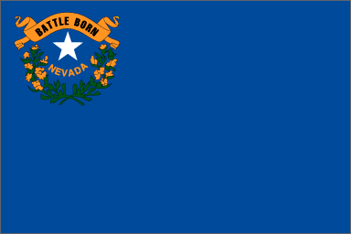 | nevada

Mountain Daylight Savings Time → Pacific Daylight Savings Time:

Zeitgewinn 1 Stunde
117 | 1520 | Wells
139 | 1659 | Ely
118 | 1777 | Panaca
 | utah

Pacific Daylight Savings Time → Mountain Daylight Savings Time:

Zeitverlust 1 Stunde
78 | 1855 | Cedar City

9. Tag / Sonntag, 13. Juli 2008
(132 mi – 212 km)

 |  | cedar breaks national monument
 |  | Markagunt Plateau
58 | 1913 | Panguitch
21 | 1934 | Rubys Inn
20 | 1954 | bryce canyon national park
20 | 1974 | Rubys Inn
13 | 1987 | Cannonville

10. Tag / Montag, 14. Juli 2008
(199 mi – 320 km)

 |  | kodachrome basin state park
 |  | Cottonwood Canyon Road (S. 206)
 |  | Grosvenor Arch
 |  | Paria Contact Station
 |  | Coyote Buttes South
 |  | Paria Canyon “the wave”
 |  | Wire Pass-Buckskin Gulch
 |  | Paria Movie Set
100 | 2087 | Kanab
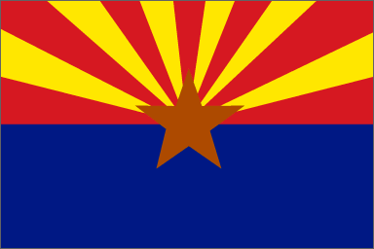 | arizona

Mountain Daylight Savings Time → Mountain Standard Time:

Zeitgewinn 1 Stunde
39 | 2126 | Jacob Lake
60 | 2186 | grand canyon national park – north rim

11. Tag / Dienstag, 15. Juli 2008
(159 mi – 256 km)

60 | 2246 | Jacob Lake
 |  | Vermillion Cliffs
41 | 2287 | Marble Canyon
 |  | Navajo Bridge
 |  | Horseshoe Bend
38 | 2325 | Page
 |  | Navajo Mountain Road
10 | 2335 | Antelope Canyons
10 | 2345 | Page

12. Tag / Mittwoch, 16. Juli 2008
(137 mi – 220 km)

81 | 2426 | Cameron
56 | 2482 | grand canyon national park – south rim

13. Tag / Donnerstag, 17. Juli 2008
(109 mi – 175 km)

79 | 2561 | Flaggstaff
 |  | wupatki – sunset crater – walnut canyon nm ?
30 | 2591 | Sedona

14. Tag / Freitag, 18. Juli 2008
(361 mi – 581 km)

20 | 2611 | montezuma castle national monument
15 | 2626 | tuzigoot national monument
32 | 2658 | (bei) Prescott
46 | 2704 | Ash Fork
119 | 2823 | Kingman
 | nevada

Mountain Standard Time → Pacific Daylight Savings Time:

kein Zeitunterschied
79 | 2902 | Boulder City – Hoover Dam
 |  | lake mead national recreation area
 |  | Moapa Valley Drive (S. 312)
50 | 2952 | valley of fire state park

15. Tag / Samstag, 19. Juli 2008
(99 mi – 159 km)

49 | 3001 | las vegas
 |  | Red Rock Canyon Loop Drive (S. 313)
50 | 3051 | las vegas

16. Tag / Sonntag, 20. Juli 2008
(352 mi – 566 km)

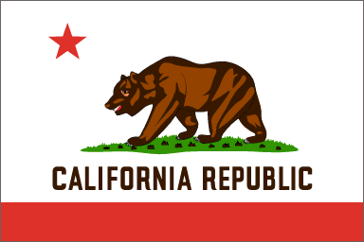 | california
222 | 3273 | Mojave
63 | 3336 | bakersfield
67 | 3403 | Visalia

 |  | alt. Route (+ 158 mi)
76 | 3127 | Amargosa Valley
 | california
 |  | Death Valley (S. 316)
23 | 3150 | Death Valley Junction
55 | 3205 | DEATH VALLEY NATIONAL PARK – Furnace Creek Inn
17 | 3222 | DEATH VALLEY NATIONAL PARK – Badwater
45 | 3267 | DEATH VALLEY NATIONAL PARK – Stovepipe Wells
74 | 3341 | Olancha
90 | 3431 | Mojave

17. Tag / Montag, 21. Juli 2008
(172 mi – 277 km)

51 | 3454 | sequoia national park
 |  | kings canyon national park
80 | 3534 | fresno
41 | 3575 | Coarsegold

18. Tag / Dienstag, 22. Juli 2008
(102 mi – 164 km)

48 | 3623 | yosemite national park – yosemite village
 |  | Tioga Pass (S. 321)
54 | 3677 | yosemite national park – tuolumne meadows

19. Tag / Mittwoch, 23. Juli 2008
(187 mi – 301 km)

 |  | Tioga Pass (S. 321)
20 | 3697 | Mono Lake
15 | 3712 | Bodie State Historic Park
15 | 3727 | Bridgeport
93 | 3820 | South Lake Tahoe
 |  | Lake Tahoe (S. 323)
30 | 3850 | Tahoe City
14 | 3864 | Truckee

20. Tag / Donnerstag, 24. Juli 2008
(285 mi – 459 km)

75 | 3939 | Quincy
69 | 4008 | Mill Creek
 |  | lassen volcanic national park
 |  | Lassen Park Road (S. 325)
141 | 4149 | Canby

21. Tag / Freitag, 25. Juli 2008
(160 mi – 257 km)

40 | 4189 | lava beds national monument
20 | 4209 | Tulelake
 | oregon
15 | 4224 | Klamath Falls
85 | 4309 | crater lake national park

22. Tag / Samstag, 26. Juli 2008
(453 mi – 729 km)

28 | 4337 | Diamond Lake
 |  | Rogue Umpqua Scenic Byway (S. 300)
73 | 4410 | Roseburg
72 | 4482 | Reedsport
 |  | oregon dunes national recreation area
 |  | Central Oregon Coast (S. 296)
21 | 4503 | Florence
 |  | Central Oregon Coast (S. 296)
119 | 4622 | Tillamook
65 | 4687 | Astoria
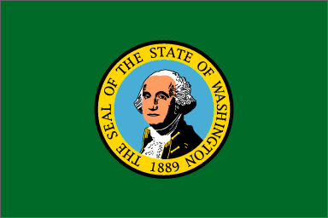 | washington
59 | 4746 | Longview
16 | 4762 | Castle Rock

23. Tag / Sonntag, 27. Juli 2008
(174 mi – 280 km)

40 | 4802 | Mount saint helens national volcanic monument
40 | 4842 | Castle Rock
49 | 4891 | Morton
45 | 4936 | Mount rainier national park – paradise

24. Tag / Montag, 28. Juli 2008
(209 mi – 336 km)

51 | 4987 | Mount rainier national park – sunrise
55 | 5042 | Enumclaw
39 | 5081 | Seattle
64 | 5145 | Burlington

25. Tag / Dienstag, 29. Juli 2008
(297 mi – 478 km)

68 | 5213 | Newhalem
 |  | north cascades national park
 |  | North Cascades Highway (S. 281)
50 | 5263 | Newhalem
61 | 5324 | Sedro Woolley
 |  | Mount Baker Scenic Byway (S. 279)
68 | 5392 | Mount Baker/Mount Shuksan
50 | 5442 | Sumas

26. Tag / Mittwoch, 30. Juli 2008
(46 mi – 74 km)

 | british columbia
46 | 5488 | vancouver

27. Tag / Donnerstag, 31. Juli 2008
(0 mi – 0 km)

vancouver

28. Tag / Freitag, 1. August 2008
(0 mi – 0 km)

 | 5488 | vancouver international airport
 | 8832 km

17.35 AC854 Abflug Vancouver

29. Tag / Samstag, 2. August 2008
(0 mi)

11.10 09:35 Ankunft London (-Heathrow)

12.55 AC9604 Abflug London (-Heathrow)
16.20 02:25 Ankunft Wien

Seitenangaben beziehen sich auf das Buch
"USA Highways & Byways"

